INCREMENTAL HAEMODIALYSIS SUSQI PROJECT REPORT

Carbon footprint breakdown of HD, UK
Start/End of Project: Feb 2022 – ongoing
Date of Report: April 2023
Team Members: E. Murray, J. Traynor, K. Craig, A. Doak, C. Grant, M. Findlay, R. Hutton et al
Background:
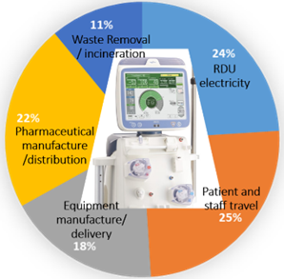
HD generates 3.7 tonnes CO2e per
patient year… equal to 50% of persons’ annual
carbon footprint.[2]

Those starting dialysis have residual urine output.
If this is >600ml/day (and no other exclusion factors)
an individualized ‘incremental’ dialysis prescription
can be adopted for improved quality of life (QoL).

Residual kidney function (RKF) is a predictor of morbidity and
mortality. Its loss is accelerated by periods of hypoperfusion and
ischaemia that occur during HD, hence incremental protocols may
preserve RKF and avoiding hypovolaemic ‘crashes’ is salient.
An additional theorised benefit is reduced requirements for iron and erthyropoietin agents through preservation of RKF and reducing blood losses on dialysis.

It is essential to ensure this does not lead to harm through insufficient dialysis adequacy; ‘stKtV weekly’ > 2.0 is widely considered ‘adequate’ dialysis based on combined HD + urinary clearances.

Specific Aims:
# To establish a twice weekly incremental HD option for patients under the care of NHS Greater Glasgow & Clyde.
# Set up of semi-automated monitoring to ensure dialysis adequacy.
# To improve value, as measured by triple bottom line assessment.
Methods:
- Assessed existing evidence and safety data.
- Determined equations for integrating dialysis adequacy monitoring/reports into existing IT software, calculating a combined urinary and HD-associated clearance to provide a single measure of ‘adequacy’ (stKtV of >= 2).
- Protocol and patient information sheet for incremental HD written, with involvement of patients; communicated protocol with wider team so responsible staff members aware of protocol and requirements.
Measurement:
Patient outcomes: QoL assessed with EQ-5D and Leicester Uraemic Symptom Scale (LUSS) and compared to a contemporary 3x weekly HD cohort. Caldicott approval and EQ-5D-5L access were granted.
Population outcomes: Interrogated the IT system (by dialysis prescription and by dialysis session), and cases reviewed to confirm accuracy, including indication for twice weekly (ie incremental and not decremental patients). Number of patients and duration of incremental protocol assessed.
Environmental and economic sustainability: Environmental / carbon and financial impacts estimated based on data from existing evidence [1,2,3,4], adjusted to account for 33% less patient travel, consumables, waste, and machine energy use; but no change in pharmaceuticals, staff time or travel, or building energy use.
Social sustainability: hospital days are usually a negative outcome for friends, family, and society; these were calculated from IT system interrogation of patient time spent on an incremental protocol, and compared to incident HD data previously published from the same centre [5].
Results:
Population outcomes: 22 patients have commenced on incremental (twice weekly) HD. Eleven are current on the iHD protocol. Mean age 70 (± 15), equal sex ratio, 36% with DM. Median duration of iHD thus far: 219 days (IQR 220); equating to 17.1 patient years.

Patient outcomes:
- One switch to 3/wk due to K+>6, another two due to fluid and potassium rising, two for falling dialysis adequacy, one transplanted, four died from acute illnesses unrelated to their dialysis-dependence and a fourth withdrew from dialysis.
- QoL data for 11 iHD patients; average health rating on EQ-5D visual analogue scale for iHD was improved but did not reach statistical significance; iHD score 59.4, SD 21.3; standard HD score 52.6, SD 20.7, p=0.6). LUSS1 examined the number of symptoms present across different domains, LUSS 2 the total number of symptoms, and LUSS 3 their intrusivity, with non-inferiority demonstrated across all three: 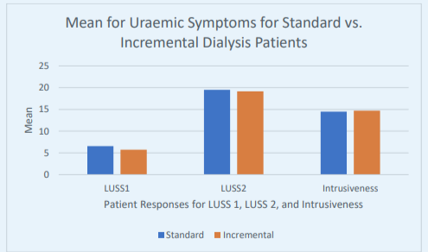
- Theoretical benefit for patients through maintenance of residual kidney function, associated with a morbidity and mortality benefit (not measured in this data).
- Additional patients may potentially utilise the same pathways for monitoring the ‘decremental’ frail, elderly patients in whom dialysis is a palliative treatment; these patients are not included, though do represent potential additional gains in QoL and value.

Environmental sustainability: Estimated savings of 0.8 tonnes CO2e per patient year spent on incremental HD, i.e. approx. 13.7 tonnes CO2e thus far. [1,2] Additional reduction in water use, waste water, and air pollution for those attending twice weekly.

Economic sustainability: Estimated savings of between £4,800 and £8,000 per patient year on incremental HD. [3,4] With a cumulative 17.1 patient years so far, a rough estimate of savings to date would be £109,000 for our unit. Only additional cost is the monthly urine collection bottle and testing for urinary urea.

Social sustainability: iHD patients had fewer in-patient days; median 32 (± 54) /1000 patient days, compared to an average ‘new start’ HD 51/1000 days [5].

Discussion:
The main concern in this project was ensuring safety and dialysis adequacy, hence focus was on generating the systems to ensure this would occur. Specifically, consideration was given to patient selection, monthly urine collection and bloods for monitoring adequacy, triggers for moving to three times weekly, and integrated IT to provide a single quantified adequacy outcome.
Conclusions:
Incremental HD is a good QoL option for certain patients and offers high value with reduced environmental and cost impact. We need to embed urine measurement into habitual care behaviours to ensure concordance with the protocol. With this in mind, poster and PIL are being distributed and SCNs have been asked to remind all HD staff, and all staff to record HD prescription accurately. Full impact of the change is yet to be measured as we expect expansion of uptake.

References and Resources
- Connor A, Lillywhite R, Cooke MW. The carbon footprints of home and in-center maintenance hemodialysis in the United Kingdom. Hemodial Int Hemodial Int; 2011;15:39–51.
- Kanagasundaram S. Personal communication. 2022.
- Roberts G, Holmes J, Williams G, Chess J, Hartfiel N, Charles JM, et al. Current costs of dialysis modalities: A comprehensive analysis within the United Kingdom. Perit Dial Int Published Online First: 24 January 2022. doi:10.1177/08968608211061126
- Torreggiani M, Fois A, Chatrenet A, Nielsen L, Gendrot L, Longhitano E, et al. Incremental and Personalized Hemodialysis Start: A New Standard of Care. Kidney Int Reports 2022; 7:1049–1061.
- Murray E, Eid M, Traynor JP, Stevenson KS, Kasthuri R, Kingsmore DB, et al. The first 365 days on haemodialysis: Variation in the haemodialysis access journey and its associated burden. Nephrol Dial Transplant 2018; 33:1244–1250.

Appendices
- SQUIRE | SQUIRE 2.0 Guidelines (squire-statement.org)
- Home | Sustainable Quality Improvement (susqi.org)

