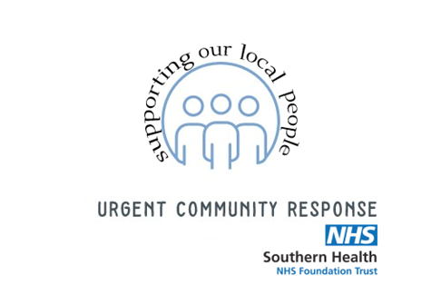

Provision of a Dedicated Vehicle to Improve the Efficiency of the Initial Assessment Process within an Urgent Community Response Service
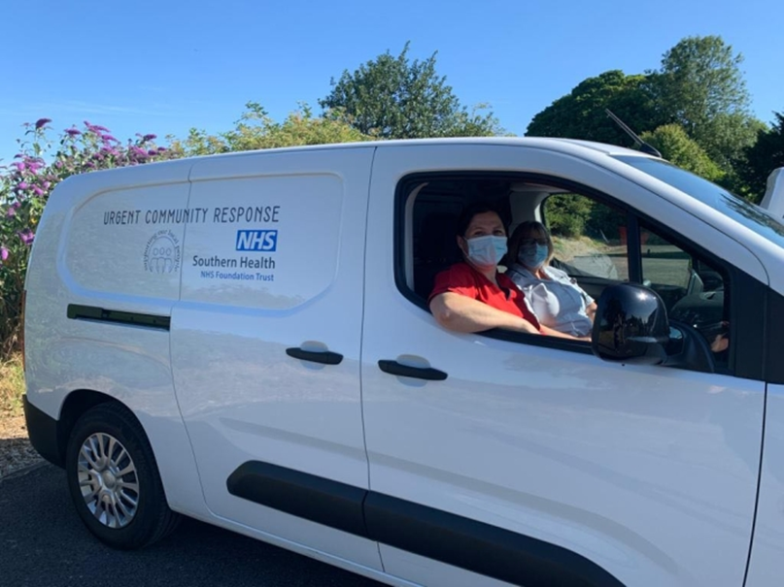

Topic Area

Please identify (more than one option may be selected)

Adaptation | ☒ | Communications and engagement | ☐ | Estates and facilities (energy, waste, water) | ☐ | Food, catering  and nutrition | ☐
Funding and  financial mechanisms | ☐ | Medicines | ☐ | Research, innovation and offsetting | ☐ | Strategic ambition | ☐
Supply chain and procurement | ☐ | Sustainable  models of care | ☒ | Travel and transport | ☒ | Workforce, networks and system leadership | ☐
Green/blue space and biodiversity | ☐ | Digital transformation | ☐ | Sustainability education | ☐
Other (please specify):
  - *Topics aligned with the 12 Greener NHS workstreams (NHS England) are shaded.

Key message / aim
As an Advanced Clinical Practitioner (ACP) working within an Urgent Community Response team, a service improvement project was proposed to improve the efficiency of the initial assessment process for patients during an acute phase of illness, who are at imminent risk of hospital admission.
The implementation for change was through the provision of a dedicated electric vehicle, staffed by one ACP and one Health Care Support Worker (HCSW), to attend to a patient, and have immediate access to all the essential diagnostic tools, mobility aids and transfer equipment; thus, enabling a safe, appropriate, and timely diagnosis, with immediate commencement of treatment in their own home. This also reduced our omissions and contribution to air pollution in and around our local area.

What was the problem?

It was identified that our team were spending much more time per patient during the initial assessment than the estimated 2 hours proposed in our initial service implementation plan. This was because all clinicians would carry just a basic observation kit and venepuncture kit in their own vehicles. Therefore, should the patient require any further diagnostic tests such as an ECG or bladder scan, or they required mobility aids and equipment, these would have to be arranged, collected and then taken to the patient in addition to their initial assessment. Our demographic area is also very large with some patients living up to an hour away from our service base. An example taken from an audit revealed one patient took 5 hours of clinical time, 3 team members and 3 separate vehicles on the road. This potentially caused a delay to the patient receiving a diagnosis and treatment plan, and also resulted in multiple staff and vehicles having to travel to the same patient, and increasing our carbon footprint.

What was the solution?

The provision of a dedicated vehicle which held all the necessary diagnostic tools and essential mobility and transfer aids, reduced the time and manpower required to safely diagnose and treat a patient at home. In turn this also reduced the number of vehicles travelling to each patient and avoided the need of an emergency ambulance being deployed, or having to engage any other community services. The choice of electric vehicle was decided to make the service environmentally sustainable.
What were the challenges?
The waiting time for the appropriate vehicle took some time due to increased demand nationally.
A clear standard operating procedure and staff vehicle user pack was completed to ensure everyone was safe and competent to drive a fully electric automatic vehicle. There were some challenges with the processes surrounding how the vehicle could be charged overnight and how the expenses for the electric charging could be managed. However, this was facilitated by having an electric charging point outside our main office, and getting a fuel card dedicated for use of the company vehicle. We also had some occasional difficulties with charging the vehicle over the winter as the charging port froze, but this was a local issue and something we can address ready for next winter.

What were the results/Impact?

Patient outcomes: Over the last 12 months, a total of 635 patients were seen, of which 82% remained at home. Each of these patients were seen by the appropriate person and they had immediate access to any essential mobility aids or transfer equipment to ensure they could remain safely at home.
Environmental impact: Road transport is a major source of air pollutants with 34% of Nitrogen Oxide contributing to 80% of concentrations at the roadside (Local Government Association 2023). Each of our patients were visited within two hours of referral by our dedicated fully electric vehicle which unlike petrol and diesel vehicles has zero exhaust emissions. Therefore, it does not release carbon into the atmosphere and is helping to keep the air in our local area cleaner (e-on Energy 2023).
As our vehicle is fully electric it is also helping to reduce noise pollution. According to e-on Energy 2023, noise from conventional vehicles affects human health and damages the environment. The World Health Organization estimates that the noise impact from road traffic is second only to pollution as the biggest environmental impact of vehicles. Several of our patients have expressed how reassuring it is to see our vehicle arrive outside their home as they can identify us by our logo, and they are pleased that our service has modernised to consider how we can reduce our environmental impact whilst also providing such an essential service.

Financial impacts: With average costs for a petrol or diesel vehicle costing over £1.63 per litre, having a fully electric vehicle has taken this average cost down to 34p per kWh2. Current research suggests that on average the cost to “fuel” an electric vehicle for 8,000 mile a year is 61% cheaper than a petrol equivalent (This is Money, 2023). As it does not have an internal combustion engine, the electric vehicle also has significantly fewer moving parts, thus the maintenance costs are also likely to be lower (e-on Energy, 2023).
Since we have started using our dedicated vehicle, we have also seen a reduction in our staffs average monthly fuel expense claims as they are using the dedicated vehicle on average once a week instead of their personal cars.
This model has been identified locally as a model of excellence and won the Health Hero’s award for best collaborative emergency service 2023 and will be replicated across Hampshire.

What were the learning points?

There has been some operational challenges such as ensuring the vehicle is regularly stocked and that all staff are given time to complete the paperwork to ensure we have a clear and tracible audit trail. We have also identified that not all staff feel confident to drive a larger vehicle, but we have suitably accommodated their wishes and paired them with a staff member who is happy to drive.

Next steps

Our service would like to purchase an additional lease vehicle so we can reach more of our patients and provide the same level of improved service efficiency. Also, because we carry a Raisor Chair, specialist lifting equipment, and have skilled clinicians, we are also working with the 111 service to navigate the referral processes which would enable us to be further utilised as a first responder in partnership with our integrated falls and frailty car. This would be to respond to elderly patients who have sustained a non-injurious fall at home and thus further reduce the need to deploy an emergency ambulance.

What the team and/or patients and carers had to say
“That's what I enjoy the most is, knowing that we've got the van full of equipment and we can actually prevent a hospital admission. We can put all the things they need in place because we have it ready to give to them in the van. This helps the patient and their family to feel comfortable and reassured that they will be properly supported when they are unwell. (HCSW working within UCR)
“It massively helps their safety. If we identify that someone needs a walking aid because they're unsafe on their feet, we would normally be gone for a few hours trying to get one to them, or it might be the weekend and we will have to order the equipment in for delivery the next day. Having the van, now means we have got it right there and then so that the patient doesn’t need to wait 12-24 hours for that equipment to be issued”. (ACP working within UCR)
“I felt so reassured when I saw the Urgent Response Van pull up outside my mothers’ home. She had fallen on the floor, and we had been told by 999 that the ambulance crew would not be able to get to her for several hours. Luckily my mother was already being supported by the team, so I called them for help. They were with us within 15 minutes. They were able to give my mother a full assessment, get her safely up off of the floor, and support her to safely remain at home. They took her bloods, got the results the same day and started her on a course of antibiotics. She had a new urine infection, so the team monitored her progress every day for the next 5 days. It made such a difference to us that she didn’t have to go into hospital and with UCRs support she recovered quite quickly”. (Family member of a patient supported by UCR)

Resources and references

e-on Energy., 2023. The Cost of Charging an Electric Vehicle. E-On Energy UK. Available at: https://www.eonenergy.com/electric-vehicle-charging/running-costs-and-benefits.html

Local Government Association., 2023. The Case for Electric Vehicles. Improvement and Development Agency for Local Government. Available at: https://www.local.gov.uk/case-electric-vehicles

This is Money.co.uk., 2022. Would an electric car save you money. This is Money, Financial Website of the year. Available at: https://www.thisismoney.co.uk/money/cars/article-10714829/Would-electric-car-save-money-Study-breaks-costs.html

Want to know more?

Contact 1:
- Name: Sue Norman
- Role: Therapy Lead Advanced Clinical Practitioner
- Email: susan.norman@southernhealth.nhs.uk
- Location & NHS Region if within the UK: North Hampshire
- Partner organisations involved: [Name of partner organisation(s); Southern Health NHS Foundation Trust
- Has this project or story been made public in any form before? No

If available, please provide details of an additional contact to best enable others interested in your project to reach you in future.

Contact 2:
- Name: Naomi Purdie
- Role: Consultant Nurse Practitioner
- Email: naomi.purdie@southernhealth.nhs.uk
- Location & NHS Region if within the UK: Same as Contact 1

