Sustainability in QI (SusQI) workshop FAQs

The sustainable value equation - how do you arrive at a figure?
The overarching goal of SusQI is to improve patient and/or population outcomes while addressing environmental, financial, and social impact. While we consider and measure all elements of the equation, we can't combine them to arrive at a single figure. The aim is to better understand the true impact of services and improvements and make balanced decisions, just as we would in clinical care. It can be helpful to describe in terms of a ‘family of measures’. See / share this example of a family of measures template Family of Measures with sustainable value example.

Prevention Principle - How can we apply the prevention principle within the scope of small scale or secondary care focused QI?
Prevention is by far the most impactful principle in sustainable healthcare. Guide people to think about levels of prevention and related changes ideas, according to the stage of disease, as illustrated in the diagram below. Some interventions overlap between different levels.
Example: Osteoporosis prevention for perimenopausal women
- Risk assessment (FRAX score)
- Calcium and vitamin D advice
- Weight bearing exercises
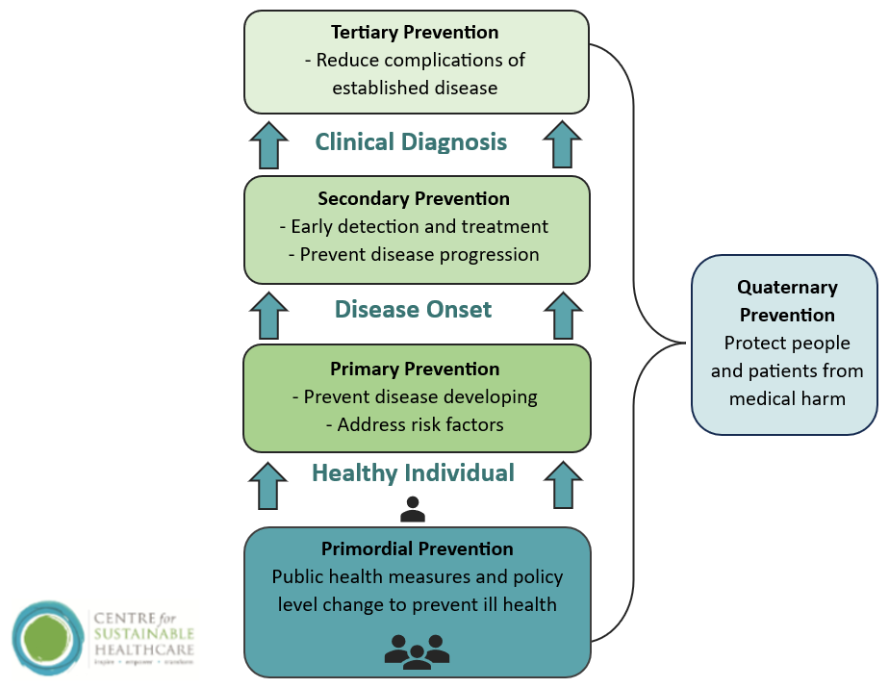

Social determinants - How can we consider applying the social determinants of health?
Always encourage people to consider the social determinants of health within the system or quality issue they are studying. The scanning for social determinants table Templates | Centre for Sustainable Healthcare helps to identify the socially-determined root causes for a problem, enabling consideration to be given to the greatest impacts, where we may find out information, and consider interventions to prevent these problems occurring. It is important to engage service users about the challenges and potential problems to understand a broader perspective and impacts that the healthcare professions that provide the service may not have considered. Whilst they may not be able to directly tackle these within their service or scope of their project, the activity is helpful to draw out root cause issues and health inequalities, which may lead to further studying of the system and change ideas. There may be change ideas relating to improved access to services, improved accessible information provision, or a referral pathway to outside agencies. If it’s clear there is a root cause of an issue and it’s not within the scope of the project or project team to tackle, there are ways professionals can contact those who may have some influence and/or advocate for patient groups. It can be helpful to discuss the power of healthcare professionals as a trusted voice. Healthcare professionals as the Most Trusted Professions Veracity Index 2023 (ipsos.com)

Measuring social determinants: There is no one way to measure social determinants of health, it will depend on the individual project. Often understanding social determinants will include some data analysis of your own patient cohort. This document created by East London Foundation Trust (ELFT) Conducting-Health-Equity-Data-Analysis may be useful if you consider how to apply it to your

own organisation, consider approaching your data analytics team for support.

Below are just a few suggestions for understanding social determinants of health in your area/locality – it is unlikely that you will be able to measure the impact of your change on these measures, but you can comment on your consideration and potential impact.

Loneliness Index (Age UK): https://www.ageuk.org.uk/our-impact/policy-research/loneliness-research-and-resources/loneliness-maps/
Social Deprivation Index: http://dclgapps.communities.gov.uk/imd/iod_index.html
Air Quality Data: https://uk-air.defra.gov.uk/
Tree equity - Tree Equity Score UK

Measuring social impact – are there any standardised measures for measuring social impact?
There is no one way to measure social impact and it will depend on the individual project, often measuring social impact will include using a survey, questionnaire or using observation. Surveys are not easy to develop and administer, so wherever possible seek existing surveys that have been validated.
Social impact may include understanding the patient, carer and families or staff experience of the service or changes you are making. This document produced by the health foundation includes helpful guidance and a list of examples of page 23. MeasuringPatientExperience.pdf
Measuring social impact, avoiding bias in surveys?
If you are creating your own survey, it is important to test it out with a small group of your target audience. This will help identify any issues with interpretation and understanding. Like any data collection method, it is important to define your objectives before drafting the survey. Additionally, ensure that your survey questions are well-constructed, and if possible, seek guidance from someone experienced in survey design.
To enhance response rates, consider factors such as the survey's length, appropriate delivery methods (online or paper copy), and how you intend to follow-up. Clearly communicate to your audience the purpose of collecting data and the advantages of their participation. Lastly, incorporate measures in your design, collection, and analysis processes to address confidentiality concerns.
Measuring social impact - how many measures should we have for social impact?
Considering and measuring social impact and adding social value when making changes should not be secondary, the scanning for social impact table Templates | Centre for Sustainable Healthcare helps us to consider all potential impacts of our current system and planned changes, but it is unlikely we can measure all. We can use this activity to focus on 1 or 2 measures which are most effective at measuring the impact of the change we are making, and that we are skilled enough and are able to administer. It’s important not to collect too much data that we are not going to utilise.
Measuring social impact - should/ can we include social impact on the supply chain?
How or if you choose to focus on the social impact of the supply chain will depend on the individual project. This may be difficult to measure in terms of the impact of your change(s) in a QI project if we have limited information about the social impact of current products/ products we’re switching from, but we may still be able to comment on our consideration of these issues to highlight them if appropriate.
If your project includes change(s) relating to a specific product, equipment, material there are an increasing number of product selection / impacts tools in use which have social value criteria such as:
- Product locally manufactured
- Supports local jobs
- Co-designed with end user

An example of a tool that considers social impact:

The Decision Support Tool - The Sustainable Healthcare in Newcastle (SHINE) Report 2019-2020¹ identified key action areas for addressing climate change, from which it developed a Sustainable Impact Assessment (SIA). This information has been adapted to create a Decision Support Tool to Compare Sustainability of Clinical Products. See here for a PDF version of the tool.
Some other helpful links for sustainable procurement:
- Healthcare Without Harm Sustainable Procurement Resources.
- UNDP Guidelines for Sustainable Procurement of Healthcare Commodities and Services.
- Global Green and Health Hospitals. Sustainable Procurement Guide.
- Sustainable Procurement Hierarchy Guidance | WRAP and info graphic Focus-on-Procurement-Emissions
- NHS Central Commercial Function Hub (CCF) Sustainable Procurement pages
If you would like to find out more about sustainable procurement, CSH has sustainability in healthcare procurement course, you can find out more here

Carbon Footprinting - How do we explain the carbon footprint reduction for an avoided admission or early discharge when there will be another patient occupying the bed straight away?
This is best explained or calculated as a reduction in emissions per patient or patient pathway, even though we accept the bed will be filled, in the longer term and if scaled we can start to drive down overall admissions and reduce waiting times. You may also want to consider how the change(s) implemented relieve overall pressure on the system and the impacts of allocating time and/or resources to higher value interventions. We recognise it is really challenging with increasing pressure on waiting lists and with more people projected to be living with multiple long-term conditions, this further highlights the need to focus on the prevention and patient empowerment principles.
Carbon Footprinting - What and how much should I consider when carbon foot-printing my project?
The first step in carrying out a carbon foot-printing study is to define the goal and scope, in QI it’s likely you are trying to quantify the impact of a specific change(s) within your QI project. It’s important to set clear boundaries for your carbon footprint study and create an inventory of the resources you expect to change because of your project. Document what is included and excluded in your study and any assumptions made. It is also important to document where you sourced the information of emissions factors. See the step-by-step guide in CSH’s measuring environmental impact guide here Templates | Centre for Sustainable Healthcare .
Carbon Footprinting - what if we can't get all the information we need?
Sometimes we don’t have to start from scratch, and we can take carbon footprints from published literature and incorporate those into our calculations. Greener NHS have developed carbon footprints for various units of healthcare activities including an inpatient bed day, outpatient appointment, A&E visits etc. If your project is focussing on something more specific, try HealthcareLCA.com, a new database which contains hundreds of published articles that have estimated the carbon footprint of medical items, services, and pathways. Just bear in mind that these carbon footprints will not be site specific to your organisations and you’ll also need to read the assumption and limitations to make sure they are suitable for your project.
Resources:

- Greener NHS units of healthcare activity: can be found on the measuring the impact document on SusQI.org
- HealthcareLCA.com
- Resource for surgery - https://pubmed.ncbi.nlm.nih.gov/32516230/
- Resource for medicines (launching Feb 24) https://www.yewmaker.com/mcf-classifier
- Database of inhaler carbon footprints https://www.prescqipp.info/our-resources/bulletins/bulletin-295-inhaler-carbon-footprint/
- Sterilisation: Minimising carbon and financial costs of steam sterilisation and packaging of reusable surgical instruments - PubMed (nih.gov)
- PPE: Environmental impact of personal protective equipment distributed for use by health and social care services in England in the first six months of the COVID-19 pandemic - PubMed (nih.gov)
- Post your question on the CSH carbon footprinting for healthcare network – someone else might be undertaking a similar project
Making assumptions is also okay, just be clear in documenting any assumptions as well as listing what you have excluded from your study.

Non carbon method: Remember you can also use non-carbon footprint method to demonstrate environmental impact. if there is not enough time to do a full carbon footprint and your project clearly led to a reduction in resource use (and did not lead to an increase in another resource) you could choose a non-carbon method to show the reduction in the scale of the environmental impact. Measure the number of resources used before vs the number of resources used after the improvement is implemented. E.g. reduction in PPE use, number of gloves and masks before change and after change or tracked over time.

The disadvantage of the non-carbon method is that it does not allow you to compare the impact of projects which have led to the reduction in the use of different resources.

Carbon Footprinting - Our project is likely to have other environmental impacts e.g. air pollution, can we measure this?
This will be difficult to measure effectively in the scope of a QI project, however, if your project has for example reduced patient or staff travel you can comment on the consideration and potential impact on air pollution as it’s important to highlight the environmental impact.
Local councils must measure air pollution, we encourage healthcare professionals to engage in conversations with them to raise awareness and implement local monitoring https://uk-air.defra.gov.uk/aqma/
We are aware of the below tools for measuring air pollution, but do not have experience in using them for improvement work currently.
NOx to NO2 Calculator | LAQM (defra.gov.uk)
Air Pollution Calculator (cleanairhub.org.uk)
Carbon Footprinting - How can we best present carbon emission data to audiences?
You can easily convert CO2e into more understandable metrics. For example, distance travelled by car or trees planted. The book How Bad Are Bananas? By Mike Berners-Lee has a wide range of carbon calculations for everyday products or activities.
- Miles driven in an average petrol car: 0.337 kgCO2e per mile (BEIS 2023)
- Taking a bath: 1kg CO2e per bath (Mike Berners-Lee)
- A 4-oz cheeseburger: 3.2 kgCO2e (Mike Berners-Lee)
- A pair of jeans: 19 kgCO2e (Mike Berners-Lee)
- One mature tree approximately absorbed 25 kgCO2e per year (ecotree.green)
- One person flying return from London to Hong Kong (economy class): 3.5 tonnes CO2e (Mike Berners-Lee)
Calculation example
Your SusQI project saves 500 kgCO2e per year. To convert this into equivalent miles driven, divide your project savings by the emission factor for an average petrol car. You can then use google maps to convert this into journeys.
500kgCO2e / 0.337 kgCO2e = 1,483.7 miles per year, which is the same as driving from London to Manchester 7.4 times in an average petrol car.

