1. The University of Reading – bringing sustainability to education: NET ZERO BY 2030?

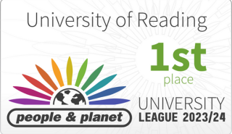
The University of Reading has made a 61% reduction in carbon emissions since 2008-09, our baseline year.
How have we achieved this?
This blog series will describe the steps taken by the University of Reading to reduce our carbon emissions and become the number one greenest university in the UK (People and Planet league 2023-24). We submit to a range of bodies to ensure wider scrutiny to validate our practice across our organisation.
Over the next few weeks, I will share the practices and steps taken to reduce our carbon emissions over the past 14 years, with a focus on Pharmacy education, and how we will continue to work towards net zero by 2030.

