Summary 2023
UK Legislation
UK Climate Change Act 2008
- The first global legally binding climate change mitigation target set by a country
- Committed the UK to reducing greenhouse gas (GHG) emissions by 80% by 2050 (compared to levels in 1990) and provided a framework to deliver these requirements
- In 2019, the Committee on Climate Change, established in the Act, committed the UK government to reduce GHG emissions by 100% (net zero) by 2050.

The Paris Agreement 2015
- This Agreement, a legally bound international treaty involving 200 countries, vowed to cut GHG emissions in an attempt to limit the rise in global temperatures to ‘well below’ 2°c and ‘purse efforts’ to limit temperature increase to 1.5°c
- Each country’s contribution to cutting emissions would be reviewed every five years

Health and Social Care Act 2022
- This legislation, which came into effect in July 2022, is the first legislation addressing the response of healthcare to climate change.
- It is now the legal duty of the NHS to consider climate in decision-making, complying with the Climate Change Act, 2008 and Environment Act, 2021 as well as adapting to current and predicated impacts of climate change

Scientific Updates
Stockholm Resilience Centre - Planetary Boundaries – 2023 Update
- In 2009, scientists proposted nine planetary boundaries interrelated to the biophysical Earth system within which humanity can continue to grow and thrive
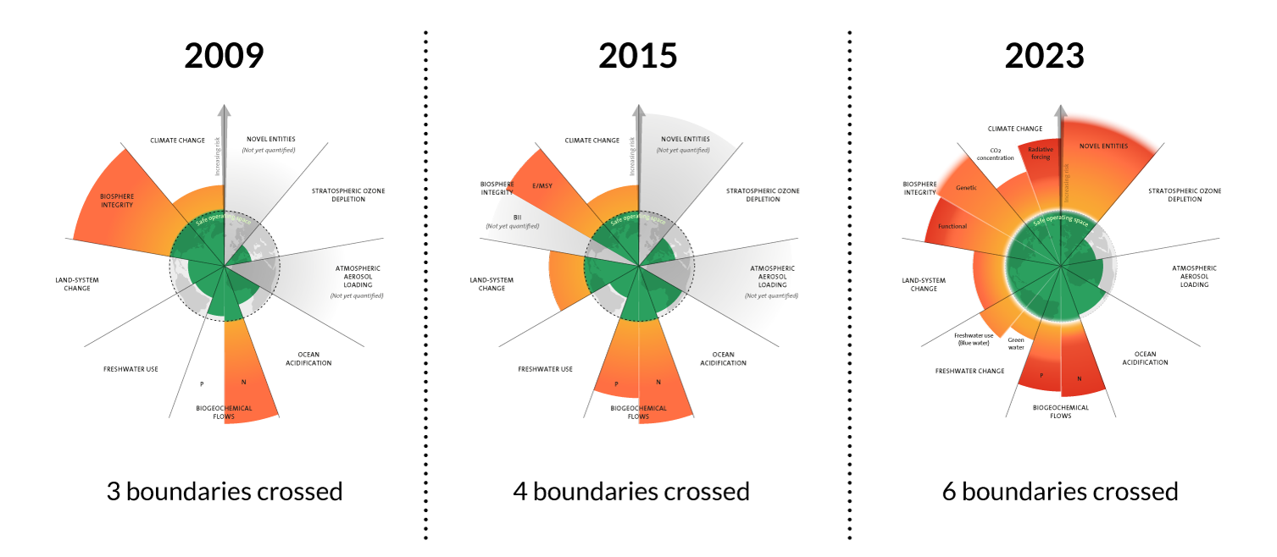
- In 2023, for the first time, all nine boundaries were quantified demonstrating 6 boundaries crossed (increased from 4 boundaries in 2015). Crossing boundaries represents increased risk of irreversible environmental damage.
The Lancet Countdown on health and climate change – 2023 Report
- The 2023 update demonstrated exponential health risks from global climate inaction including rising transmission of life-threatening infectious diseases, increasingly frequent health-threatening temperature rises and rapidly growing pressure on health systems.
- Positive news of 15.7% reduction in deaths attributable to fossil fuel-derived air pollution since 2005 and investment in clean energy exceeding that in fossil fuels.

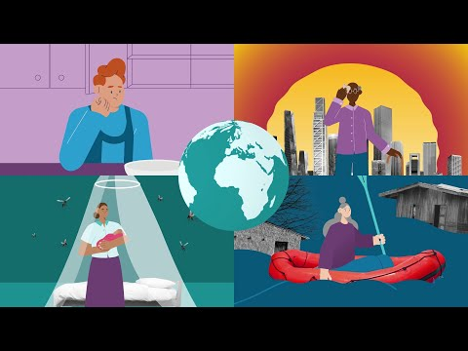

Intergovernmental Panel on Climate Change (IPCC) – 2023 Synthesis Report
- Human activity has unequivocally caused global warming (with temperatures in 2011-2020 reaching 1.1°c above that of 1850-1900) through continually increasing GHG emissions.
- This has resulted in widespread lossess and damages to nature and people disproportionately affecting vulnerable communities who have historically contributed the lease to current climate change.
- Rapid and sustained reduction in GHG emissions could slow down global warming within two decades.

Resources
Legislation
What is the 2008 Climate Change Act? - Grantham Research Institute on climate change and the environment (lse.ac.uk)
A legal duty to act - Climate Change Committee (theccc.org.uk)
The Paris Agreement | UNFCCC
New legislation places duty on NHS to tackle climate change | The BMJ

Policy updates
Planetary boundaries - Stockholm Resilience Centre
Lancet infographic - Climate Countdown 2023 (thelancet.com)
AR6 Synthesis Report: Summary for Policymakers Headline Statements (ipcc.ch)

