Service Improvement: Supporting the inclusion of environmental sustainability into improvement work at EKUHFT through education of the Improvement Team.

Contents:
Contents: 1
Background 2
Understanding the Problem 3
Problem statement 6
Designing the intervention 7
Results 9
Literature / Background Reading. 14
Background literature – importance, susQI 14
Policy 14
Education Initiatives to support susQI 16

Background
Improving the environmental sustainability of clinical practice is both a legal and professional obligation for clinicians working in the UK’s National Health Service (NHS). The NHS contributes between 4% and 5% of England’s national emissions and makes up 40% of all public sector emissions (Five years of a greener NHS). To combat this, the NHS is the first healthcare system in the world that has made a commitment written in law to deliver a net zero healthcare service (Delivering a 'Net Zero' National Health Service, Health and Social Care Act 2022). Additionally, the General Medical Council’s (GMC) Good Medical Practice outlines the duties and responsibilities of practicing clinicians, which `includes a duty to use resources responsibly, and choose sustainable solutions where it does not compromise the quality of care (Good Medical Practice 2024).

In line with national efforts to reduce emissions, East Kent Universities Hospitals NHS Foundation Trusts has recently published its first Green Plan, outlining its ambitions to contribute towards this target (EKUHFT 2026). Included as a new target is the goal of integrating environmental sustainability as a domain of the clinical quality improvement framework.

Sustainable Quality Improvement Projects (SusQI) have significant potential to improve patient care, reduce healthcare-associated carbon emissions, improve staff wellbeing and generate economic savings (CSH 2026). A significant proportion of NHS carbon emissions are resultant from medicines, equipment and waste production, all areas within the scope of clinical quality improvement projects (20%, 18%, 5% respectively. Figure 2: Delivering a Net Zero NHS). Significant work has been done nationally but non-profit organisations to support the development of SusQI including work produced by the Centre for Sustainable Healthcare (CSH).

SusQI expands the traditional quality improvement framework to challenge practitioners to redefine ‘value’ in a changing environment with growing concerns of the impacts of climate change and ecological destruction (What is SusQI). It frames value not in terms just of safety and efficiency (including financial), but utilises principles of sustainable healthcare (prevention, lean service provision, low-carbon alternatives and patient empowerment) and wider social considerations to ensure that improvements to do not compromise the ability to deliver care in the future.

Included as part of the Enhance Foundation Curriculum for Foundation Programme Trainees is the learning requirement of trainees to “identify, evaluate and embed measures of environmental sustainability as outcomes of quality improvement activity” (Enhance). Locally, within East Kent Universities Hospitals NHS Foundation Trust (EKUHFT), teaching has been delivered to foundation doctors on embedding environmental sustainability within quality improvement. Investigation following this teaching identified that trainees reported high confidence and motivation to participate in SusQI (Joseph Friel Success Form).

Integration of SusQI and environmental sustainability within quality improvement work at EKUHFT has potentially significant impact to reduced carbon emissions. The aim of this service improvement project is to improve the integration of environmental sustainability within trust wide quality improvement work.

Figure 1: Drivers and outcomes of Sustainable Quality Improvement
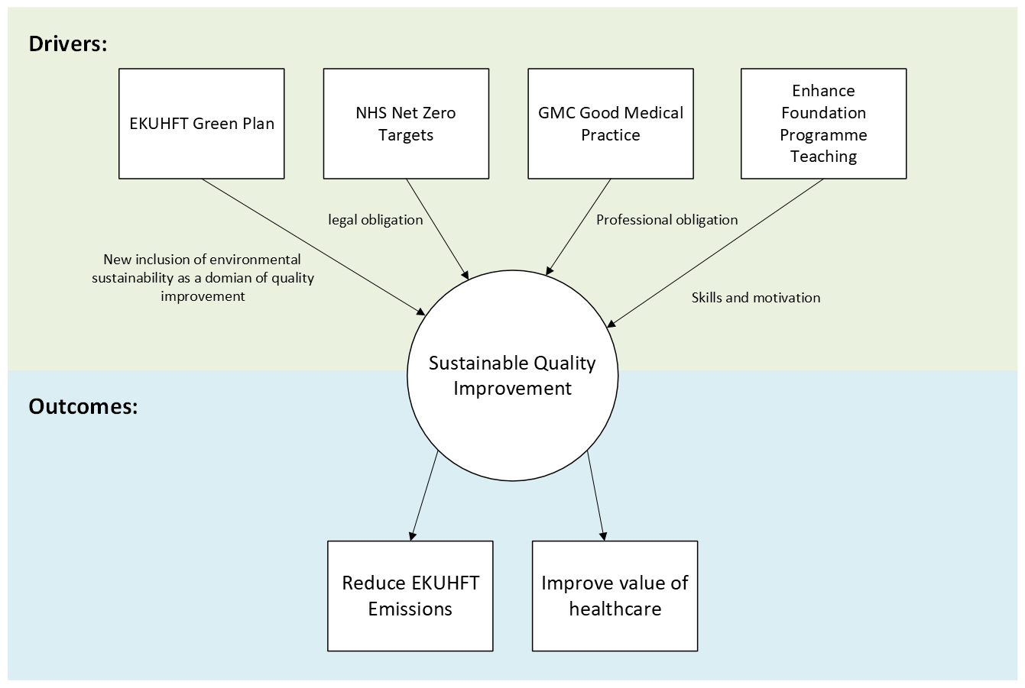

Understanding the Problem
Using the KENT project management framework (?reference) to guide the development of this project. Following initial scoping and mapping out of the quality improvement completion pathway, the trusts ‘Improvement Team’ were identified as key stakeholder with significant opportunity to influence outcomes of QIP and provide a potential high return on intervention value. Figure three outlines the mapped process. The improvement team are made of clinical and non-clinical staff who approve, mentor and collate the findings of completed quality improvement projects. They are uniquely positioned to influence the broad range of quality improvement work across the entire trust. Having decided to focus in on this target group, figure three outlines the initial scoping process using the in and out of scope framing tool.

Figure 3: In and out of scope frame
IN SCOPE | OUT OF SCOPE
Target Audience: Quality improvement mentors | Target Audience: Medical Students, Nurses, or Allied Health Professionals (unless they are QIP supervisors). QIP Supervisors (Consultants, Registrars, SAS doctors) within EKHUFT.
Process: The QIP Registration and Supervision process. | Process: The completion or success of the individual clinical projects.
Geography: EKHUFT QIP Department. | Geography: Other Trusts or GP practices.
Deliverables: Intervention to support QIP Mentors integrating environmental sustainability in EKUHFT. | Deliverables: Creating a full SusQI curriculum, running a full workshop series, or changing Trust-wide procurement policies.
Timeframe: Project completion by April 2025. | Timeframe: Long-term longitudinal follow-up (post-April).

Baseline audit of completed QIP for environmental sustainability.
In order to gain an understanding of the current state of environmental sustainability within quality improvement, a baseline audit was completed. Each completed QIP at EKUHFT is registered with the Improvements Team via a ‘success form’ which outlines the project, its aims and outcomes. This information is collated via one master spreadsheet. An audit criteria was developed based on the Centre for Sustainable Healthcare’s principles of sustainability. Each success form was reviewed for i) explicit inclusion of environmental sustainability ii) missed opportunities pertaining to each domain of sustainable healthcare (prevention, lean service pathways, patient empowerment, low-carbon alternatives).

211 completed QIPs from the last 18 months were included in the baseline audit. Of these, six projects (2.8%) explicitly included environmental sustainability (identified within the project title, problem statement, improvement idea description, or key success criteria). A further 36 projects included obvious missed opportunities for the integration of environmental sustainability.

Examples include:
- Lean Service Pathways: Reduced length of stay was achieved, but the associated environmental impact was not acknowledged.
- Prevention/Reduction: QIPs pertaining to inappropriate investigations (e.g., CT scans) and reducing unnecessary blood tests; these have an environmental impact that was not noted.
- Low Carbon Alternatives: Replacement of single-use items with reusable clinical items (e.g., kidney dishes, peak flow mouthpieces) and using PO medications instead of IV medications (e.g., paracetamol). In these cases, cost savings were identified, but the environmental impact was not.

Of the six QIPs that identified specific environmental inclusion, no projects quantified the environmental savings. One project weighed clinical waste savings differentiated by waste type but did not quantify the CO2e savings associated with the reduction in clinical waste.

Stakeholder engagement to inform the problem statement
In order to gain a better understanding of the QIP process, motivations and barriers for the inclusion of environmental sustainability and understand the best practices nationally in this space, informal interviews, surveys, group interviews and forum discussions were used to contribute towards the problem statement development.

EKUHFT improvement team, survey and group interview.
Ten members of the improvement team completed a baseline survey assessing current practices, confidence and understanding of sustainable healthcare in quality improvement. Six participants participated in an informal group interview to explore their ideas and clarify current processes and practices. Participant roles included QI practitioner, Improvement programme manager, project support administrator and other roles. Five-point Likert scales were used to assess understanding confidence and converted to three-point grouping: strongly confident (4 or 5), moderately confidence (3) and not confidence (1 or 2). 40% of participants indicated they were strongly confident with financial sustainability while only 10% indicated they were strongly confidence with environmental sustainability. Of the three domains of sustainability (social, environmental and financial), the improvement team had the least confidence supporting the inclusion of social sustainability into the projects they mentor (60% not confidence). Regarding technical skills of calculating a carbon footprint of an intervention 90% of the participants reported that they were not confident supporting project leads to do this.

Figure X. Confidence of Improvement Team Staff on supporting the integration of the following concepts into their mentoring practices.
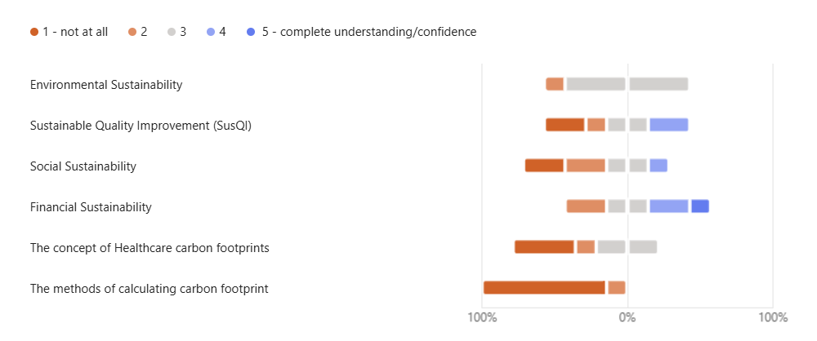

When ask to rank what potential interventions may be beneficial for improving the inclusion of environmental sustainability within QIP, the most popular option was a SusQI implementation checklist (8 votes), 1-hour introduction to SusQI lecture (7 votes) and a Written guide/toolkit (6 votes).

Informal group interview identified that simple, low-effort interventions would be the most effective and the team expressed the concern that they lack the current technical knowledge on calculating carbon footprints. Additionally, contrary to the initial scoping exercise identifying the Improvement teams as key influencers over all QIP work, participants discussed the limitation that many project leads act independently without support and there is limited opportunity for QIP mentors to influence the project if the project leads don’t register their projects until project completion. They also identified that the improvements team work includes a much broader scope than just quality improvement and that there were significant opportunities to integrate this into other work and training such as their Medilead project management training programme.

Project leads: SusQI completed at EKUHFT.
Using the baseline audit to identify projects where environmental sustainability had been explicitly discussed, project leads were invited to participate in informal interviews to discuss their experiences, challenges and opportunities for improving the inclusion of environmental sustainability in QIP at the trust. Key findings from this process identified challenges acting on projects across domains of trust operations, finding it difficult to coordinate estate and clinical working streams. Additionally, this process identified that there was very limited support or motivation from the institution to incentivise SusQI and was currently only limited to individual with strong personal motivations.

Foundation Doctor Trainees: Enhance Curriculum Recipients.
Work completed within EKUHFT’s Medical Education department has previously delivered training for foundation trainees on sustainable quality improvement and surveyed trainees to gain an understanding of their motivation to implement practice and understanding SusQI. This work indicated 90% of trainees were comfortable considering the social, financial and environmental impacts of quality improvement. (Reference – Joe’s QIP success form?)

Centre for Sustainable Healthcare: SusQI forum.
The Centre for the Sustainable Healthcare is a UK based charitable organisation that serves as the hub for SusQI in the UK (CSH). Included in their offerings are networks for healthcare professionals to connect and share SusQI work. In order to gain an understanding of how other trusts have integrated SusQI into their QIP structures, a post was added to the Sustainable Healthcare Community hub asking for input from the community. Key findings from this process included highlighting SusQI training resources for project leads, using events/awards to celebrate good SusQI practice, integrated sustainability into formal trust QI methodology processes.

Following the baseline audit, stakeholder engagement and key informant interview, a problem statement was drafted to inform the direction and development of the interventions.

Problem statement
Despite mandatory Net Zero NHS targets, professional obligations, trainee readiness and inclusion in Enhance Foundation Programme curriculum, environmental sustainability is current only included in a minority of Quality Improvement Projects at EKHUFT. Consequently, current QIPs fail to identify carbon-reduction opportunities, resulting in missed potential contribute to the Trusts Green Plan targets.

Ensuring the problem gets solved
Success for this project is defined through three key performance indicators:
- EKUHFT Improvement Team staff are empowered and supported to encourage the inclusion of environmental sustainability in quality improvement work,
- measured increase in confidence of Improvement Team staff to promote and support environmental sustainability within their projects and projects they are mentoring and,
- an increase in the proportion of completed QIPs incorporating environmental sustainability into quality improvement (long term goal, outside the scope of this current timeline).

Engaging stakeholders:
Key players include Head of Improvement, who has high influence over Improvement Team staff mentors, setting department priorities and goals. Improvement team staff, key players directly involved in QIP registration and mentoring. Additional stakeholders include EKUHFT Medical Education team as this project supports change practice following delivered curriculum material on SusQI.

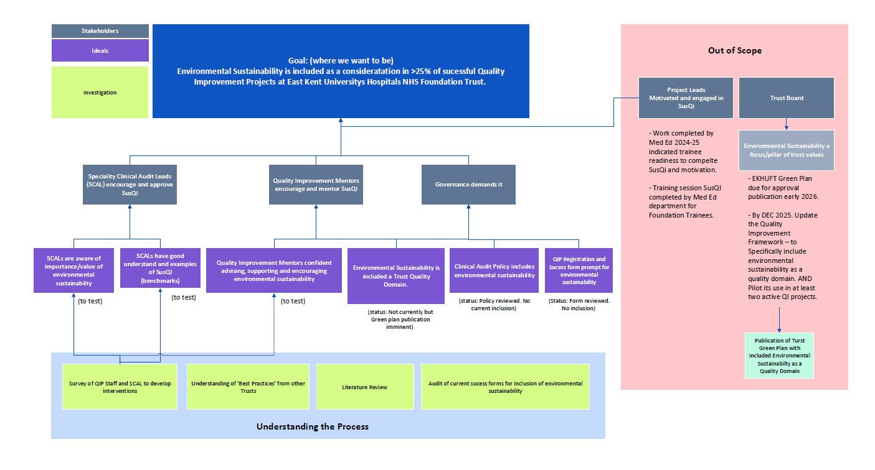

Designing the intervention
Following stakeholder engagement and review of currently available materials two interventions were developed to address the identified issues: i) delivery of 1-hour workshop, introduction to sustainability in quality improvement and ii) Interactive QIP registration triage checklist.

- Delivery of a 1-hour workshop
A 1-hour workshop was delivered to 10 members of EKUHFT’s Improvements Team. The sessions outlined sustainable healthcare, the legal and professional obligations of including sustainable healthcare in clinical practice and introduced the Centre for Sustainable Healthcare Quality Improvement Framework (SusQI). A short follow up survey was completed to identify any changes in practitioner confidence integrating sustainability into their quality improvement practices.

- Development of an interactive tool for triaging new registrations of quality improvement projects for the inclusion of sustainable healthcare.
Following identification of the missed opportunities in current quality improvement work to identify the environmental impacts (17% of completed QIP), and the identified training need of the Improvement practitioners for a simple easy to use tool that will prompt and support practitioners to engage project leads in sustainable quality improvement, an interactive pdf tool was developed to allow easy identification and integration of sustainable healthcare.

The interactive PDF takes participants through four short questions to identify the potential opportunities for inclusion of environmental sustainability. Figure X outlines this checklist and a full copy is available in appendix X.

Figure X – Interactive Registration Triage Checklist
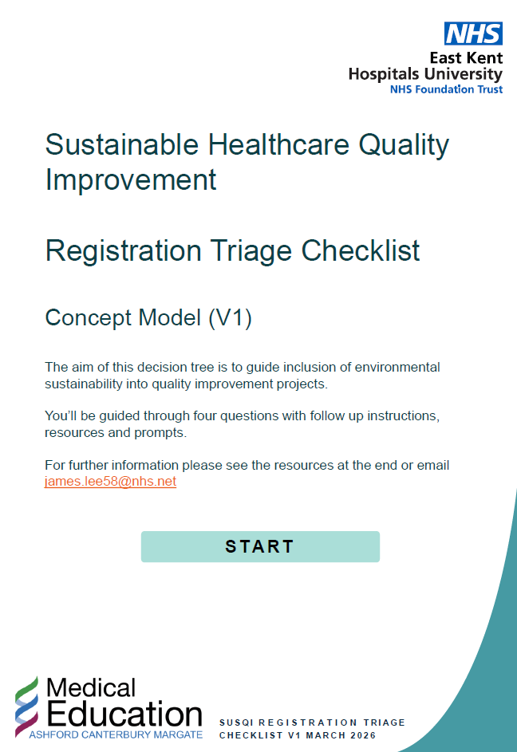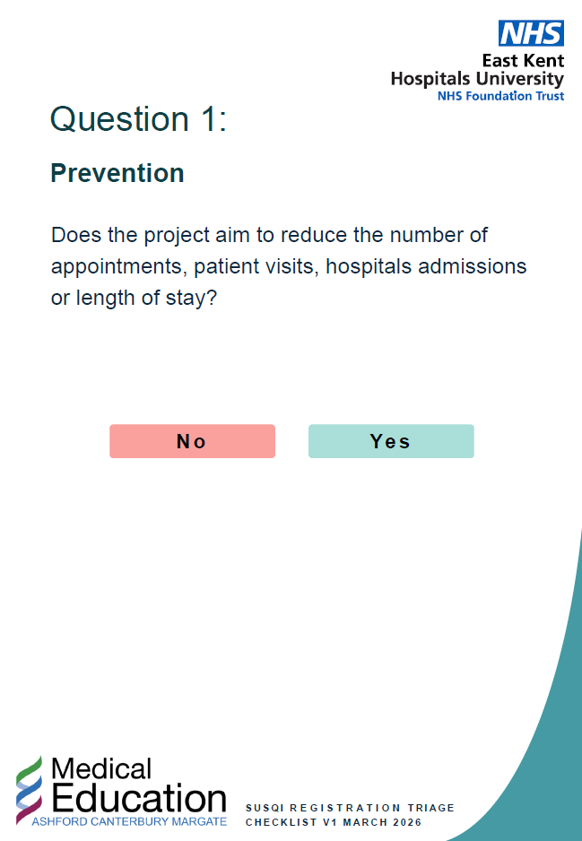
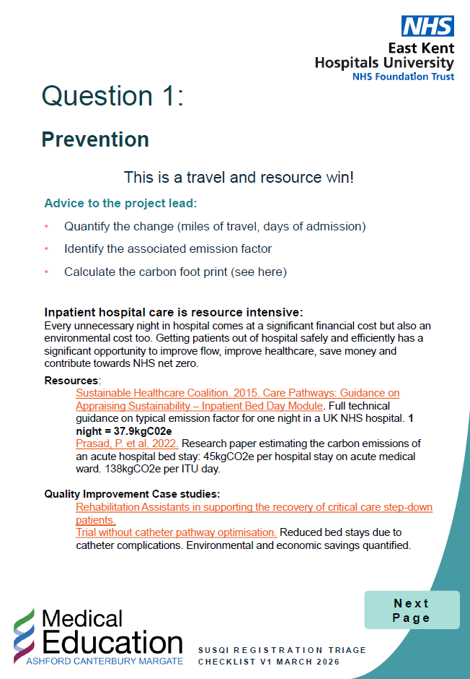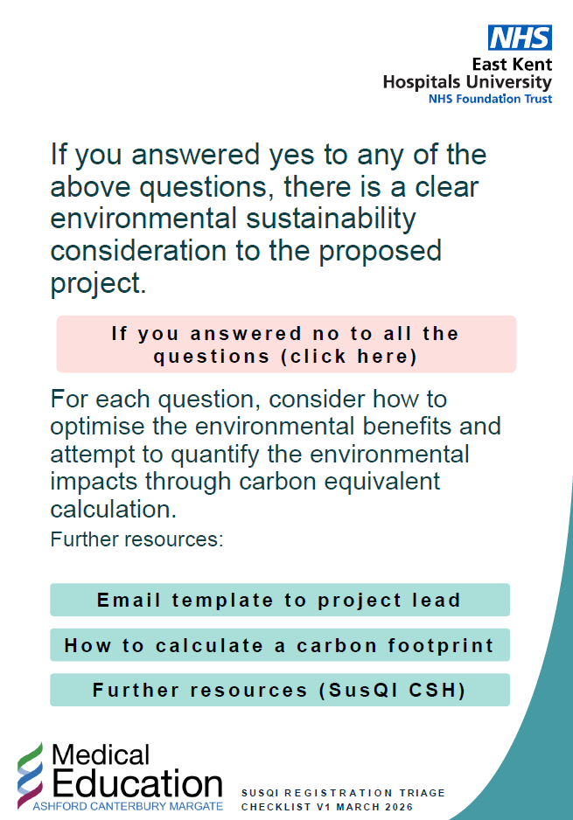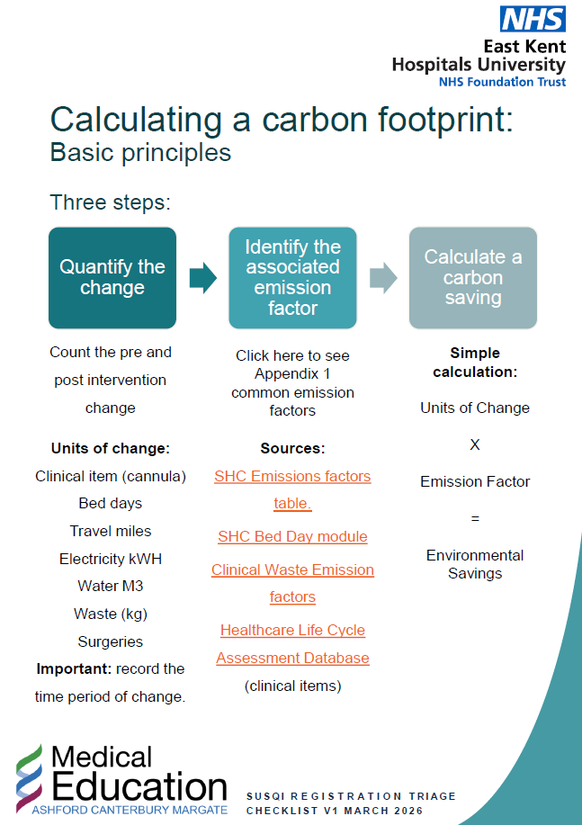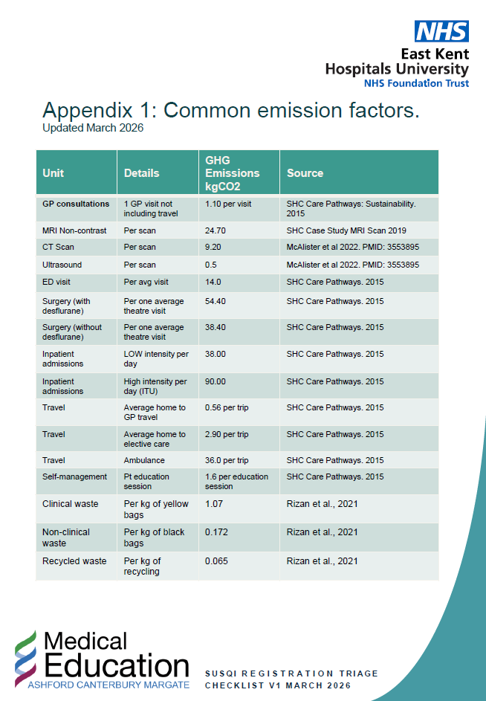
The interactive checklist was introduced to the Improvement Team Practitioners at a whole team meeting where they had the opportunity to work through the checklist using examples identified from the baseline audit where QIPs had missed the opportunity to introduce environmental sustainability. Feedback was collected from informal group feedback and practitioners also had the opportunity to provide written feedback back via an anonymous survey.

Results
In order to evaluate the designed interventions, an anonymous survey was used to identify the pre-post changes in confidence integrating sustainable healthcare into quality improvement and whether the proposed interventions would change practice. Additionally, informal feedback was collected during an Improvements Team meeting on the new triage checklist.

Survey results
Ten members of the improvements team completed the baseline survey and eight members completed the follow up, post intervention survey. Only five members where present for both the pre- and post-interventions surveys. Anonymous unique identifies where used to identify complete cases. Mean differences pre- post intervention were calculated and Wilcoxon sign-rank test was used to identify statistical significance. Although there were large differences observed pre- and post-intervention, no SusQI was identified as statistically significant.

Informal group feedback identified that although this tool had value to the improvement team practitioners in their own project management work, it would only have limited benefit for integrating sustainability into wider quality improvement work. The team identified that many QIP project leads have limited interaction with the central improvements team and only a small proportion seek mentoring advice. The team identified that the tool would have potential more benefit if it was re-framed to directly target the QIP project leads as opposed to the improvement team mentors. The project leads could use the tool at conception to identify potential inclusion of environmental sustainability and get guidance on quantifying these impacts.

Concept | Mean Pre | Mean Post | Mean Difference | Median Pre | Median Post | Wilcoxon p-value
Environmental Sustainability | 2.8 | 4 | 1.2 | 3 | 4 | 0.0625
Carbon foot-printing | 2 | 3.6 | 1.6 | 1 | 4 | 0.0625
Social Sustainability | 2 | 3.2 | 1.2 | 2 | 3 | 0.108809
Financial Sustainability | 3.4 | 4 | 0.6 | 3 | 4 | 0.083265

Pre-intervention confidence
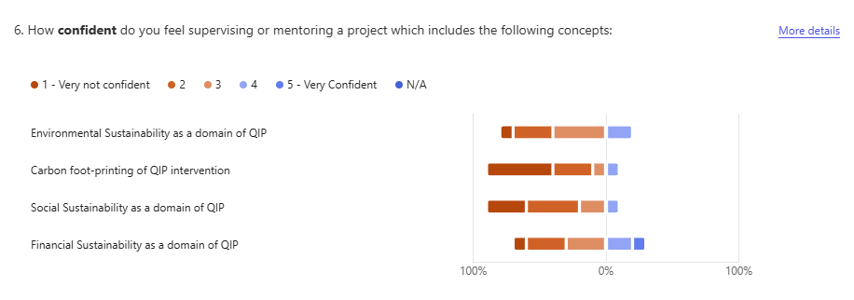
Post intervention confidence:
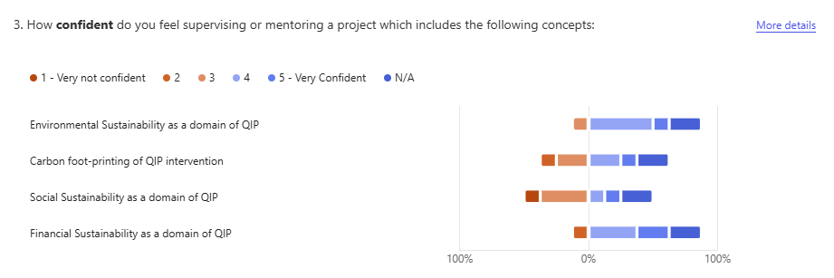

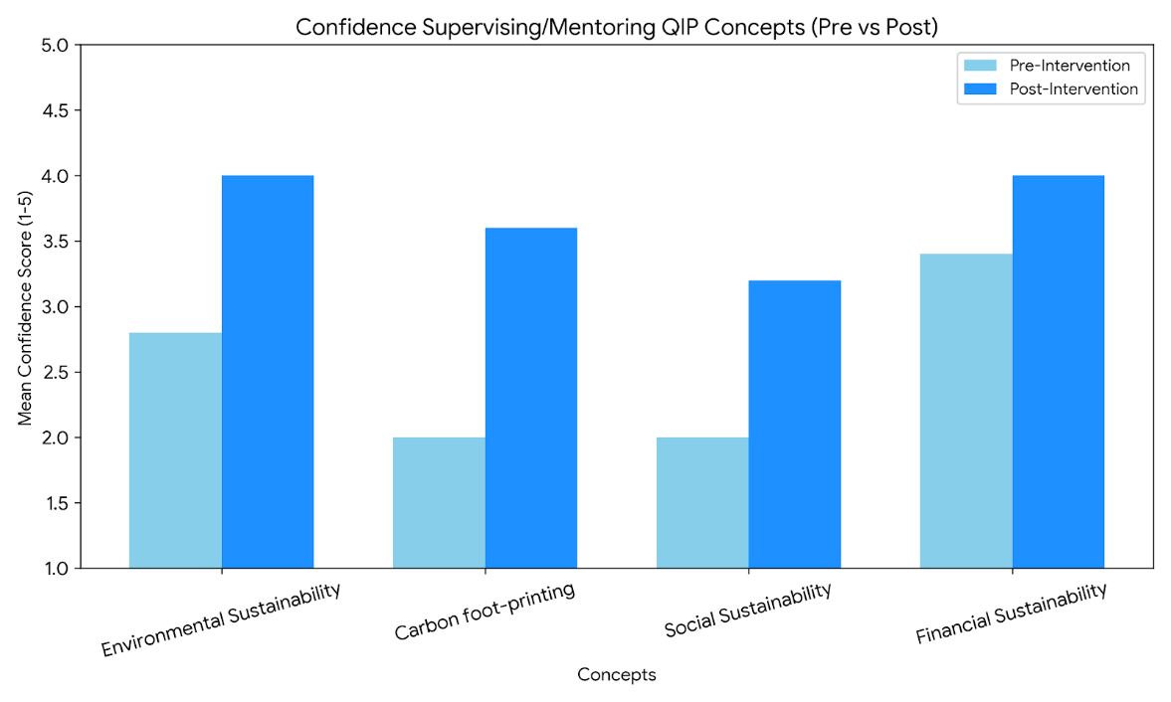

Follow up and Key Learning
The findings from this project suggest that while brief educational interventions can improve knowledge and confidence among Improvement Team practitioners, achieving measurable changes in the number and quality of SusQI projects will require broader system level integration. The next phase will focus on redesigning the interactive checklist into a project lead facing tool, enabling earlier consideration of environmental sustainability at the point of project conception. This will be piloted with selected project teams, alongside targeted feedback collection to iteratively refine usability and impact. In parallel, opportunities to embed SusQI principles into existing trust processes such as QIP registration forms, Medilead training and education programmes will be explored to normalise sustainability as a core domain of quality improvement. Engagement with external bodies including the Centre for Sustainable Healthcare and regional education networks will support alignment with best practice and wider dissemination. Finally, a repeat audit of completed QIPs will be undertaken at 6 to 12 months to evaluate whether these interventions have translated into a sustained increase in the incorporation and measurement of environmental sustainability, informing recommendations for trust wide adoption.

 | Figure: Boat chart/project on a page
 | December/January | February | February/March | March
 | KNOW | EXAMINE | NEW | TRANSFORM
Estimated Duration | 3-4 weeks | 1 month | 1 month | 1 month
Key Activities | - Understand context  - Identify key stakeholders  - Complete problem statement  - Engage with Centre for Sustainable Healthcare (CSH) | - Complete baseline audit of success forms and write up of results. (28th Jan)  - Identifying examples of good practice from CSH  - Baseline Improvement Team survey. | - Development of proposed intervention  - Delivery of SusQI introduction lecture.  - Delivery of SusQI checklist to guide inclusion. | - Share recommendations and intervention with mentors’ team.  - Observe trial period  - Re-survey Improvement Team to establish any change.
Key Meetings | - Meeting with Simon, Head of Quality Improvement (13th January) | - Project catch up with supervisor (4th Feb)  - Conduct Group intervention/workshop with Improvement Team (9th Feb)  - Meet with the CSH for stakeholder/intervention guidance (TBC)  - Meet with stakeholders: Completed SusQI at EKUHFT. | - Improvement Team meeting 23rd March to deliver interventions and get feedback on pilot.
End Products | - Key population identified.  - QIP Process mapped.  - Baseline audit scoped. | - Baseline audit completed (understanding of current inclusion)  - Baseline confidence/experience of Improvement Team  - Stakeholder engagement and key findings written up. | - Proposed intervention planned and ready for delivery | - Final Report  - Results of change in confidence of QIP mentors.  - Indication of change to practice

Literature / Background Reading.

Background literature – importance, susQI

Royal College of Surgeons - Trainees' guide to a quality improvement project. Sustainability - Chapter 5. Sustainability refers to ensuring that the change that is implemented is maintained once the members of the team have completed their projects. (Link)

Royal College of General Practitioners - WPBA –
Quality improvement Project (link) - 'important to evaluate an improvement holistically, i.e not just looking at the patient outcomes, financial savings, additional social value and environmental impact. An approach called 'sustainable value'. 'When thinking about potential solutions, consider the principles of sustainable healthcare to design holistic sustainable improvement.

Health and Social Care Act 2022 - 'Delivering a 'Net Zero' NHS - July 2022.
Outlines the responsibility and commitment of the NHS to achieve net zero.

EKHUFT - Clinical audit web pages: https://staff.ekhuft.nhs.uk/Interact/Pages/Content/Document.aspx?id=2385

Centre for Sustainable Healthcare - SusQi - https://www.susqi.org/about-4

Josephs research on SusQI (unpublished). N=31 foundation doctors. Questions on attitudes towards sustainability in QIP.
Would you like to include sustainable considerations in your QIP. Pre: 17 Post: 30.
Do you currently feel able to, or empowered to, include sustainable practices in your QIP? Pre: 4. Post: 24.
I am comfortable with creating a process map as part of a QIP. Pre: 6 Post: 30 (agree or strongly agree).
I am comfortable with considering social, financial and environmental impacts of proposed changes within QIPs. Pre: 18. Post 28. (Agree or strongly agree).

Policy
Review of current EKHUFT quality improvement / environmental sustainability policy.
Search strategy – review of policy centre for ‘quality improvement’, ‘improvement’, ‘green plan’, ‘We Care Improvement’, ‘Clinical audit policy’, ‘QI strategy’, ‘Quality account’, ‘Net Zero Plan’, ‘Sustainability Strategy’.

Clinical Audit for Improvement Policy. Version 6. Issued November 2025.
  - Policy defines clinical audit and highlights what is required to undertake audit at EKHUFT.
2.3 Trust provides advice and assistant to clinicians completing audit with assistance from appropriately trained and experienced CAID staff.
3.2 – defines audit as ‘quality improvement cycle that involves measurement of the effectiveness of healthcare against agreed and proven standards of high quality.
3.3 – definition of clinical audit standards – quantifiable statements detailing the specific aspects of patient care and/or management to measure current practice against evidence of best practice.
4.1 – purpose of policy – “to set out a framework for the conduct of clinical audit for improvement within the Trust and outlines the principles, roles, responsibilities and practices which the Trust will follow in auditing clinical practice”.
5. Section 5 Duties Roles and Responsibilities – Listed roles of doctors – however, no inclusion or requirement of a ‘supervisor’ – QIP are completed by a project lead, and the Speciality Clinical Audit Lead – leads audit within their department. Responsible for the clinical audit programme, including registration, progression of all projects and actions. Approving or declining clinical audit proposals in line with their speciality clinical audit programme and best practice criteria. .
6. Section 6 – Specific Requirements for Clinical Audit.
6.4 Programme of Clinical Audit Activity – the trust will develop and maintain an annual clinical audit programme. This is developed by the clinical audit for improvement department managers, in collaboration with clinical specialities and care groups. The for audit plan is developed between May and July each year. Audit year changing this year 1st April.
6.4.2 – the audit programme will reflect key national and local drivers with priority given to audits related to… including – directive from Trust high level committee. Trust True North Objectives.
6.4.3 – forward audit plan will be agreed by clinical specialities then shared with the ICB.
6.13.1 – data management of audits – in accordance with GDPR and Data Protection Act and NSHE Records Management CoP 2023.
Appendix E – Clinical Audit Training Programme Content – note no inclusion of sustainable quality improvement.

EKHUFT Green Plan
2.1 The green plan presents an opportunity for the trust to set out its vision for maximising cost-effectiveness while improving healthcare outcomes for patients in a changing environment and reducing the negative environmental impacts arising from Trust operations.
2.3.2 – Integrating sustainability action within existing governance structures as appropriate.

Appendx B – Understanding our impacts –
Sustainability in healthcare is not simply about doing less harm, it is about creating new value. Many actions that reduce emissions also support better patient outcomes, improve operational resilience and reduce long-term costs. ‘Meeting the climate challenge will require innovation, partnership and bold change’.

Appendix C – Actions.
Introduction of Sustainability in Action – award category in trusts annual awards.
Launch of Sustainable Future Forum, 20 active cross-group members.
Net-Zero Clinical transformation – Whole section on the need and benefit of transforming care to be more sustainable.
2.2 By DEC 2025. Update the Quality Improvement Framework – to Specifically include environmental sustainability as a quality domain. AND Pilot its use in at least two active QI projects.

EKHUFT webpage – Mission, vision and values.
Sustainability included as a strategic theme, under this theme however is only includes financial sustainability.
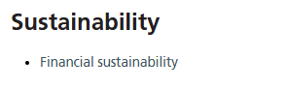

EKHUFT – Quality account – 2024-25 – Includes sustainability, only in terms of financial sustainability.

Environmental Sustainability in Quality Improvement
Sustainability – the ability for something to be maintained in the future, three main areas – economic, environmental and social. Sustainable healthcare, means delivering care in a way that maximises positive health outcomes whilst avoiding financial waste and harmful environmental and social impacts. Delivers care in way that does not compromise the health or ability to deliver healthcare in the future.
Value = improving outcomes for patients and populations / environmental, social and financial impacts. (the triple bottom line).

Pillars of sustainable healthcare (Mortimer) – prevention, patient empowerment, lean pathways, low carbon alternatives.

Studying the system – identifying opportunities – heating and electricity, water, surgical instruments in packs, medical equipment, personal protective equipment, anaesthetic drugs and gases etc. Waste outputs.

Measuring impact – carbon footprint = activity or resource use x GHG emission factor. List of certain activities is available – for example – 0.22kg COeKgm – these numbers come from lifecycle assessments.

Social impacts – through staff survey – pre-post interventions.

