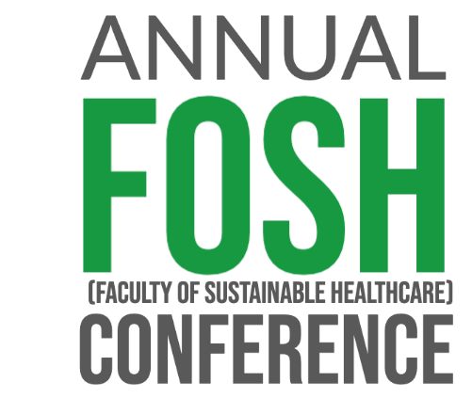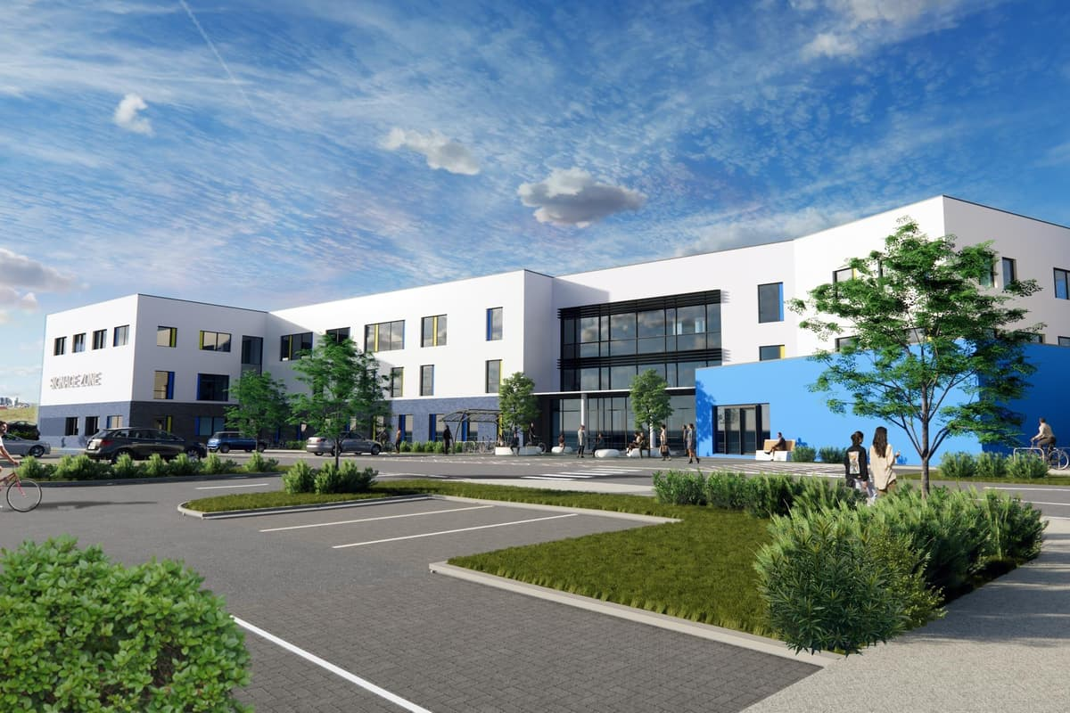

**Save the Date!**

**Friday 5th September 2025**

**Faculty of Sustainable Healthcare**

**The Faculty of Sustainable Healthcare** is proud to announce the date of their next annual conference.

Join us for a day of **sustainability talks and engagements** around the **theme of Birth to Death.**

We want to celebrate all the great work from the region and beyond.

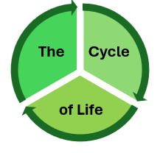

Full details will be shared in due course including registration and agenda.

The venue for this year’s event is Northumbria Health and Social Care Academy, Cramlington.

Please **save the date** in your diary and we look forward to seeing you there on the day.

