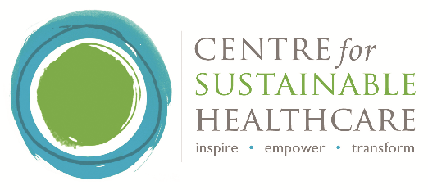
Conference: Sustainable dentistry – innovation and future proofing
Date: 29th June 2018, 9.30am – 4.30pm
Venue: The Coin Street Conference Centre, 108 Stamford Street,
South Bank, London SE1 9NH
Purpose of conference
To engage and inspire dental trainees, high street and community dentists and dental commissioners to embed sustainability in their day to day practice.

AGENDA
Session | Topics | Speakers
9.30 - 10am | Registration and Refreshments
10.00 – 11.10am  Introduction to sustainability. What is happening in NHS & PHE? Where is dentistry now? | Welcome  HEE’s position on sustainability  Working towards a healthy sustainable future  Introduction to sustainability in healthcare  Public dental health and sustainability  Sustainable dentistry from an NHS England perspective  Postgraduate dentists and sustainability | Dr Andrew Dickenson (HEE)  Lee Whitehead (HEE)  Steve Owens (PHE)  Rachel Stancliffe (CSH)  Linda Hillman (PHE)  Dr Eric Rooney (NHS England)  Dr Andrew Dickenson (HEE)
11.10 - 11.30am | Refreshments
11.30am -12.40pm  Inspiration to start. Where to go, what tools and resources are available | Carbon footprinting of dental care  Digitisation of healthcare - a sustainable solution  E-learning & 10 Tips for sustainable dentistry  Green Impact as a tool for change  Waste in dental practice  HEE/CSH Sustainable Dentistry Scholarship Programme  Sustainable dentistry projects at Manchester University | Ingeborg Steinbach (CSH)  Dr Sam Shah (NHS England)  Dr Devika Vadher (HEE) & Dr Divya Verma (Central NW London FT)  Charlotte Bonner (NUS)  Dr Ian Mills (Dean FGDP)  Sara Harford and Darshini Ramasubbu (dental scholars)  Dr Vitalia Kinakh (Manchester University)
12.40 - 1.40pm | Lunch: Networking
1.40 - 3.30pm  Innovation and embedding into practice: Dragons Den  3.30 – 3.50  Break  3.50 – 4.00  Winner announced | Workshop Programme  10 tables of 10 to develop idea  - Workshop: 30min  - Dragon’s Den pitch: 8min per table (1hr20min)  Expert Panel  - Dr Ian Mills (Dean FGDP)  - Sara Harford (Dental scholar)  - Rachel Stancliffe (CSH)  - Dr Robert Zabihi (Dentist)  - Nicola Hawkey (BDA)
4.00 – 4.30  Ways forward | Guide for Sustainable Dentistry  Sustainable Dentistry – the future  Summary of the day | Dr Brett Duane (Trinity College, Dublin University)  Dr Frances Mortimer (CSH)  Chair: Dr Paul Batchelor (independent)

