Centre for Sustainable Health Network
Dr Ruth Greer, ST7 Anaesthetist, Severn Deanery

The World Health Organisation describes climate change as the biggest threat to global health in the 21st century, yet the NHS produced 26.6 MtCO2e in 2015.
In line with the Climate Change Act (2008), NHS England set reduction targets for CO2e emissions; 34% by 2020, 50% by 2025, 80% by 2050. To achieve this, a cultural change is required to embed environmental sustainability into NHS decision-making.
The NHS Long Term Plan calls for a 2% carbon emission reduction to be achieved through ‘transforming anaesthetic practices’, supported by the recently published Environmental Strategy from the Royal College of Anaesthetists.
This seems like a monumental task… but everyone can contribute.
At North Bristol NHS Trust I established an Environmentally Sustainable Theatres working group, engaging multiple stakeholders to meet, discuss and initiate ideas to reduce our carbon footprint. Attendees included:
- Manager for the sustainability department
- Waste manager
- Theatre and ODP manager
- Environmental Awareness Representative for theatres
- Anaesthetic leads (consultant and registrar)
- Other interested parties from theatres
A team approach enabled several projects to be kick-started at once, as well as promoting initiatives already running. The more people I engaged through this group and the projects established, the greater the enthusiasm and success.
To date, the following projects are in various stages of action as a result of this group:
- Desflurane reduction campaign
- PVC recycling scheme
- Volatile recycling trial
- Recycling awareness – what can and cannot be recycled from theatres
- Reduction of single use plastic items used eg. Patient belongings bags, cups, straws
- Reducing the use of electrical items including lights left on out of hours
- Establishing a ‘Green Impact’ team within theatres
Desflurane has a significantly greater carbon footprint in comparison to other volatiles or TIVA (Sherman et al. 2012). Other trusts in our region have already successfully reduced their usage, and therefore their carbon footprint. We aim to follow suit. We have created a Sustainable Model of Care to increase awareness amongst anaesthetists of the significant impact of Desflurane on the environment.
Environmental sustainability targets and Sustainable Models of Care are now embedded into every Directorate Business Plan at North Bristol NHS Trust, a significant step forwards on our environmental journey.
There are many likeminded healthcare professionals throughout the Severn Deanery, all working towards improving environmental sustainability in the NHS. We aim to establish a ‘Green Deanery’ network, to share and link ideas from all trusts.
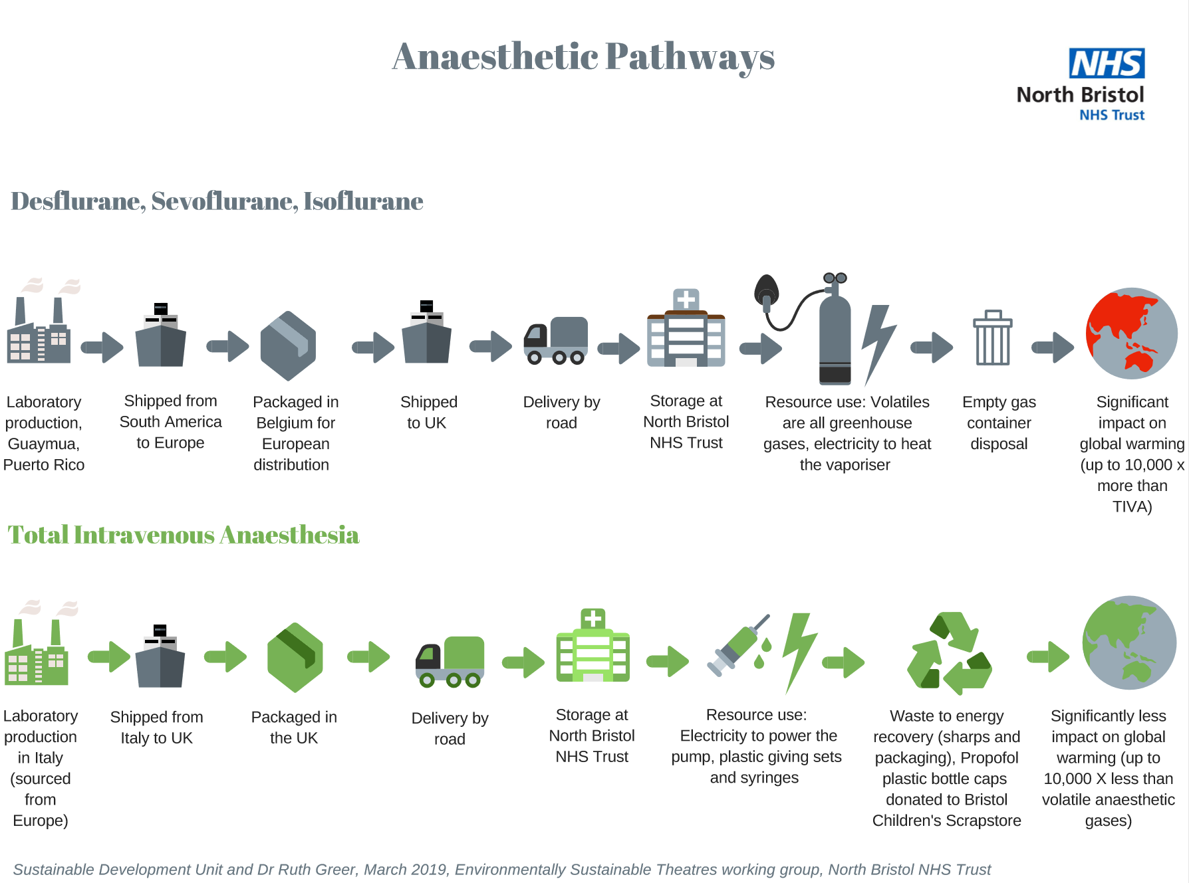

References
Sherman J. Et al. 2012. Life cycle greenhouse gas emissions of anaesthetic drugs. Anaesth Analg. 114(12)

